**Assignment 2**



# 

**Team Member** **2**

**Project Description** **4**

**Core Features** **5**

Core Feature 1 5

Core Feature 2 6

Core Feature 2 Validation Testing: 6

Core Feature 3 7

Core Feature 3 Validation Testing: 7

Core Feature 4 8

Core Feature 4 Validation Testing: 8

Core Feature 5 9

Core Feature 6 10

Core Feature 6 Validation Testing: 10

**Project Estimation** **11**

**Technology Listing** **12**

Collaborative Workspaces 12

Software 12

Tools 13

Resources 14

**Extended Features** **15**

Extended Feature 1 15

Extended Feature 1 Validation Testing: 15

Extended Feature 2 16

Extended Feature 2 Validation Testing: 16

Extended Feature 3 17

Extended Feature 3 Validation Testing: 17

Extended Feature etc. 18

Extended Feature ?? Validation Testing: 18

# Team Member

**Bowen Zhang s3617571**

**Background & Passion** - Basic coding skills and passionate about games and Artificial Intelligence.

**Skill & Interest** - Good at Coding, Learning and organizing and interested in all sorts of games and AI or advanced technologies.

**Weakness** – I’m not good at English writing.

**Role** – Organiser & programmer

**Cheng Chen s3728207**

**Background & Passion** - Had basic coding experience with VS, Pascal,

Python and Java. Strong interest in building a software.

**Skill & Interest** - Enthusiast of hardware and game building, Good at organising. Interested in coding and function developing.

**Weakness** - Weak at visual design.

**Role** - Mainly working on software structures and feature design.

**Bowen Yang s3665803**

**Background & Passion** - I have basic experience with Java programming language and program interface design.

**Skill & Interest** - Better at text editing than coding, but I am working hard to learn programming and are interested in the IT words.

**Weakness** - Probably the coding skills need to improve.

**Role** - I expect to become a competent team member that be able to do a good job of assigning tasks and be able to present their own views on the project.

**Zongming Liu s3713771**

**Background & Passion** - I know some basic coding skills and static web layout coding skills.

**Skill & Interest** - I am good at designing the website

**Weakness** - weak at coding

**Role** - design the UI and interface of the app

**Lei Guo s3516439**

**Background & Passion** - I have basic coding skills in Java, .net and web programming.

**Skill & Interest** - Good at teamwork and interesting in computer games and travelling

**Weakness** - Weak at English

**Role** - Good team member

**Zheshun Shi s3696260**

**Background & Passion** - basic Java and web programming skills.

**Skill & Interest** - interested in VR.

**Weakness** - weak at English grammar and oral speaking.

**Role** - perfect teammate.

# 

# Project Description

Our team is building a mobile application called Litab which is a combination of Tally book and Reminder. The main purpose of this application is to keeping track on personal expense and to remind user what’s coming next and what they want to buy or do in the future. Users can plan their future expense based on their monthly average spending and income and users can categorize their expense for better management. The application will also tell the user if their plan have fulfilled or short by how much as well, remind them if they need to cut their budget or create extra income to achieve their goal. Finally, this app will feature all the basic function a tally book has such as list all consumption, categories and a clean and friendly interface.

# Core Features

## Core Feature 1

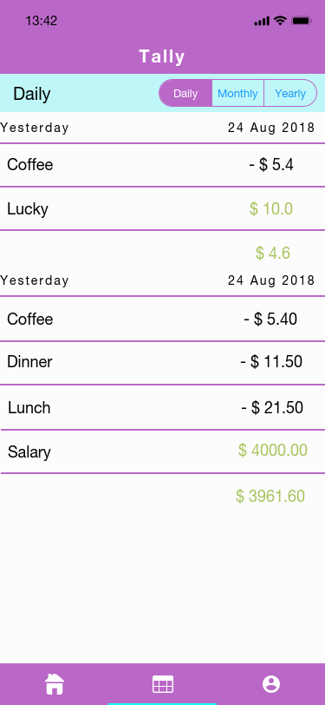

Core Feature 1 Validation Testing:

Input some income and outcome data and select the pre-coded categories. If the data are correctly recorded, this function is working properly. Input a value but do not select any of the categories. If the app prompts for a valid category, we can make sure that every data is recorded into the correct category.

**Author: Bowen Zhang Create Date: {26/08/2018 }**

## Core Feature 2

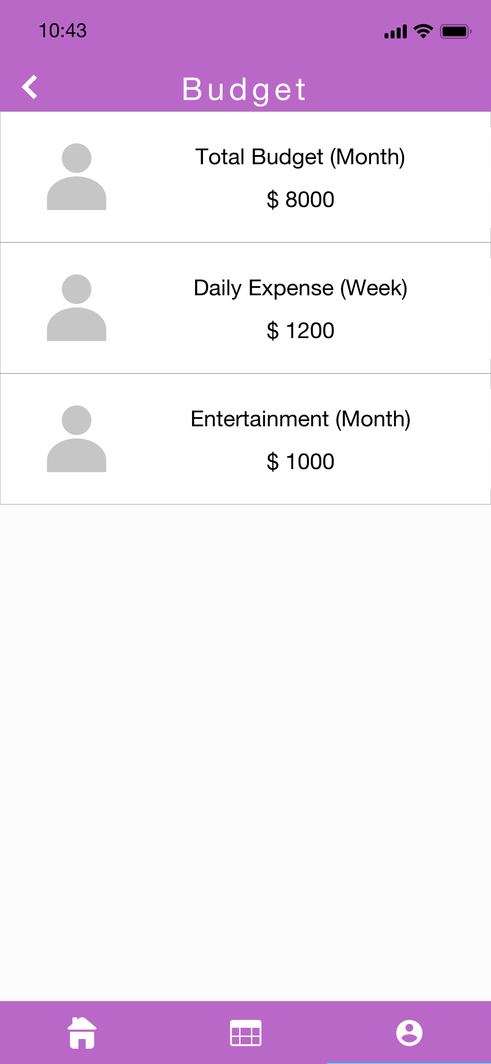

### Core Feature 2 Validation Testing:

## Set the budget for weekly and record some data to perform overspend. The users can also set the Daily expense, Entertainment budget or other budgets. If the app shows an alarm when the current spending value exceeds the budget set, this function is working properly.

**Author: { Cheng Chen} Create Date: {26 /08/2018 }**

## Core Feature 3

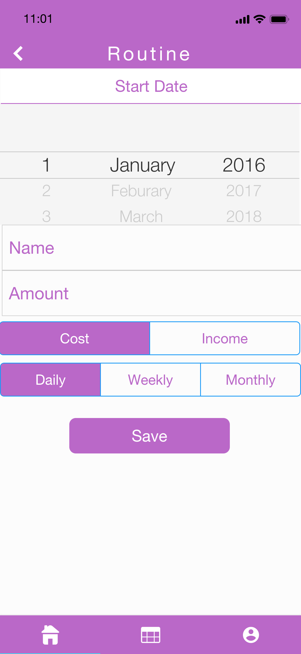

## Core Feature 3 Validation Testing:

## Input some name in the category creation menu. The app will record the data. If the category shows up on the spending input page, this function is working properly

**Author: { Bowen Zhang } Create Date: { 26/08/2018 }**

## Core Feature 4

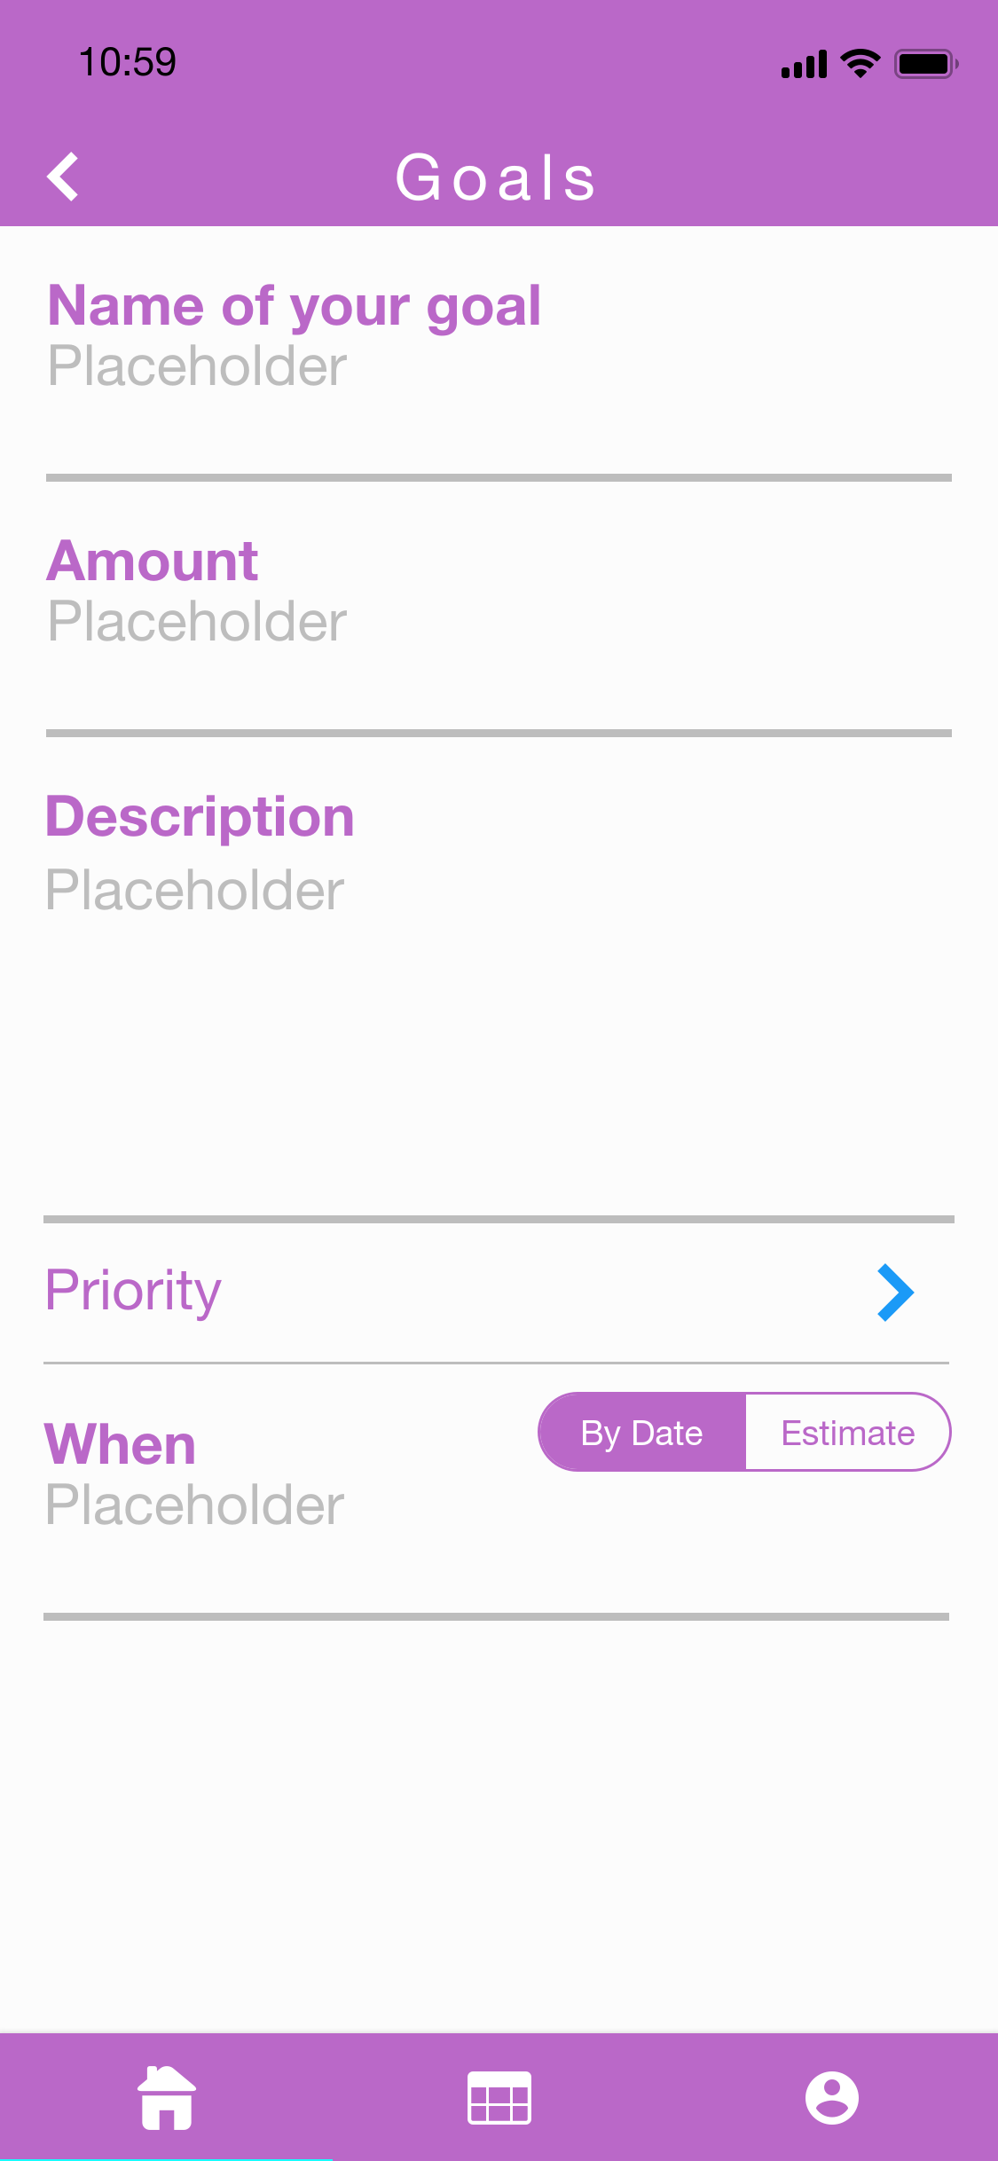

## Core Feature 4 Validation Testing:

## Set a target in money box with preferred purchase date. The app will calculate the money the users need to save or the minimum days. Users can see the details of all the things. If the app correctly shows the amount of money needed to be saved each week, this function is working properly.

**Author: { Bowen Zhang } Create Date: { 26/08/2018 }**

## Core Feature 5

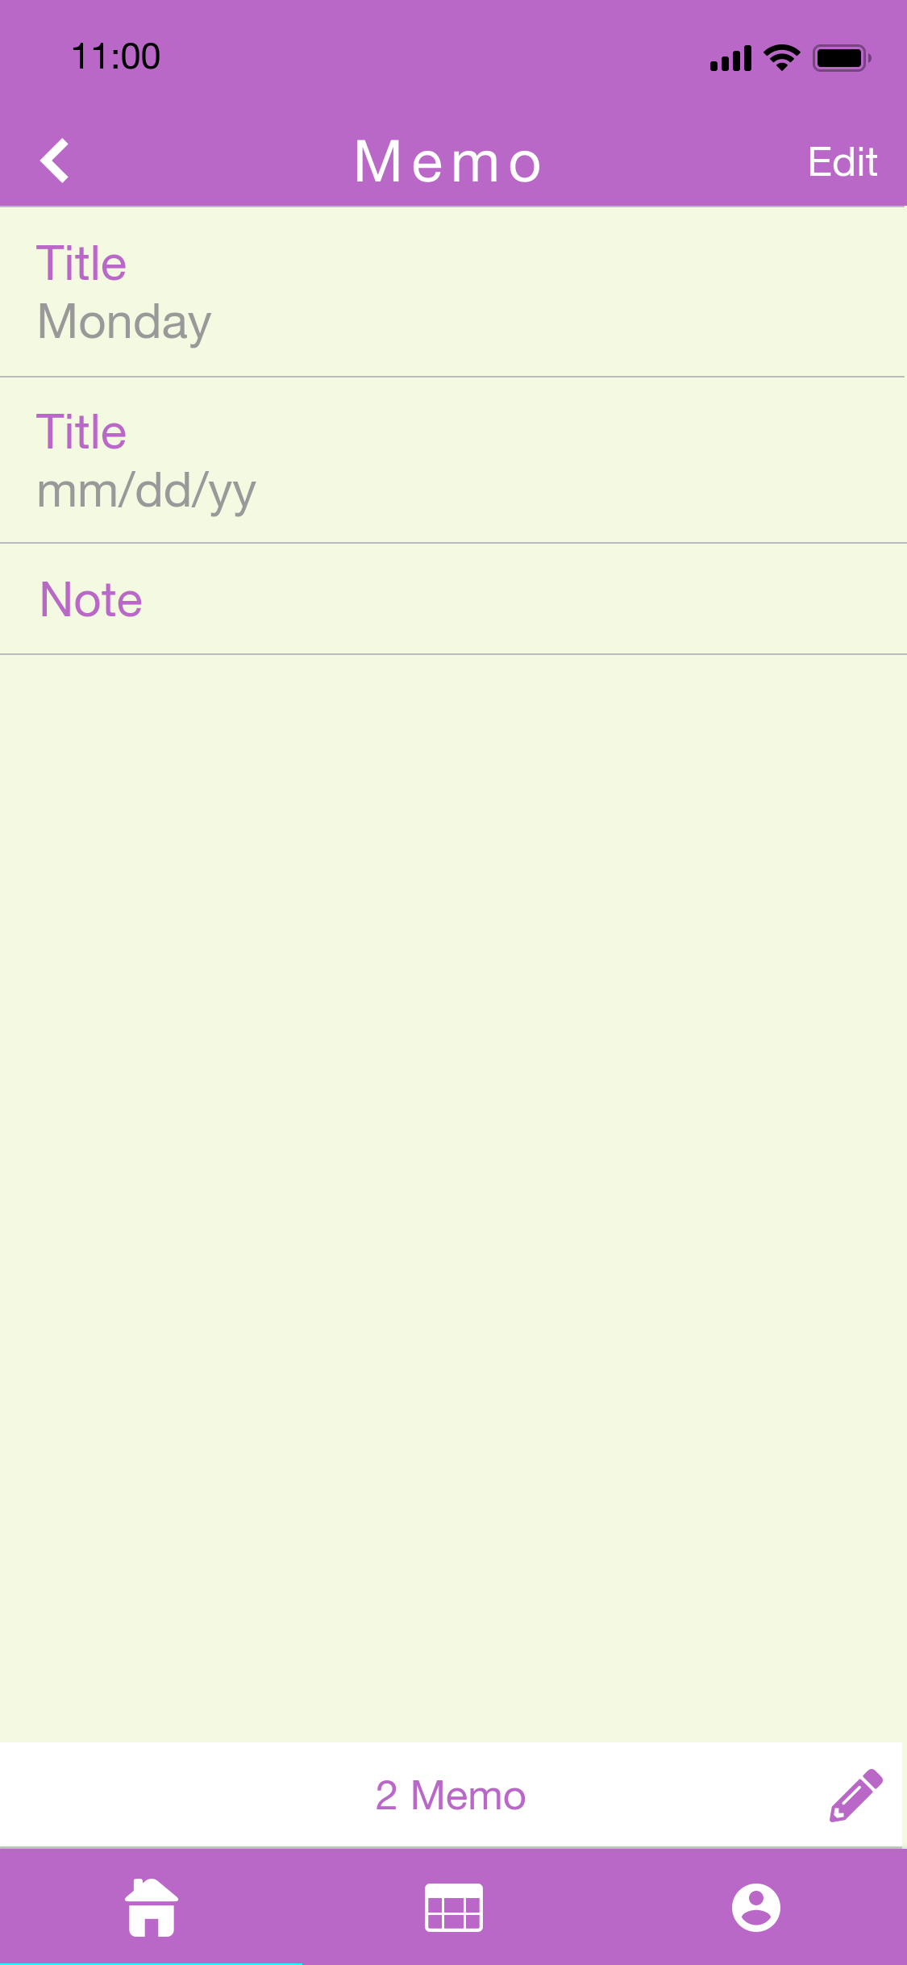

Core Feature 5 Validation Testing:

Set some notes and reminders. If the notes are correctly displayed, the notes function is working properly. If the alarm goes off at the desired time, the reminder function is working properly.

**Author: { Bowen Zhang } Create Date: { 26/08/2018 }**

# Extended Features

## Extended Feature 1

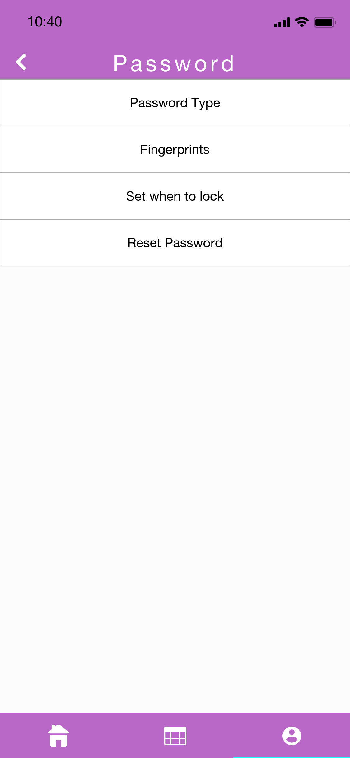

## Extended Feature 1 Validation Testing:

## Input a valid username and password. If successfully logged in, it is working properly. Input an invalid username or password. If the login failed, the login function if fully working.

**Author: {Cheng Chen } Create Date: { 07/09/2018 }**

## Extended Feature 2

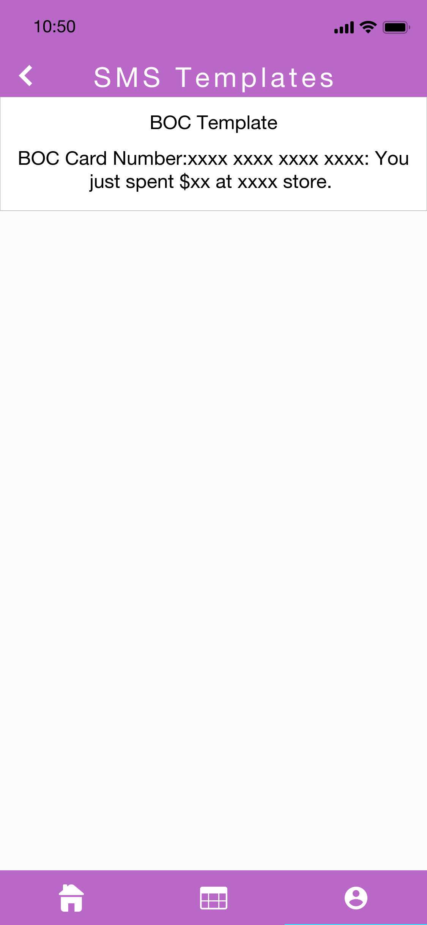

## Extended Feature 2 Validation Testing:

## Set a template and test with some text messages corresponding to the template. If the app recognizes the text message and records the correct value in the text, this function is working properly.

**Author: {Cheng Chen } Create Date: { 07/09/2018 }**

## Extended Feature 3

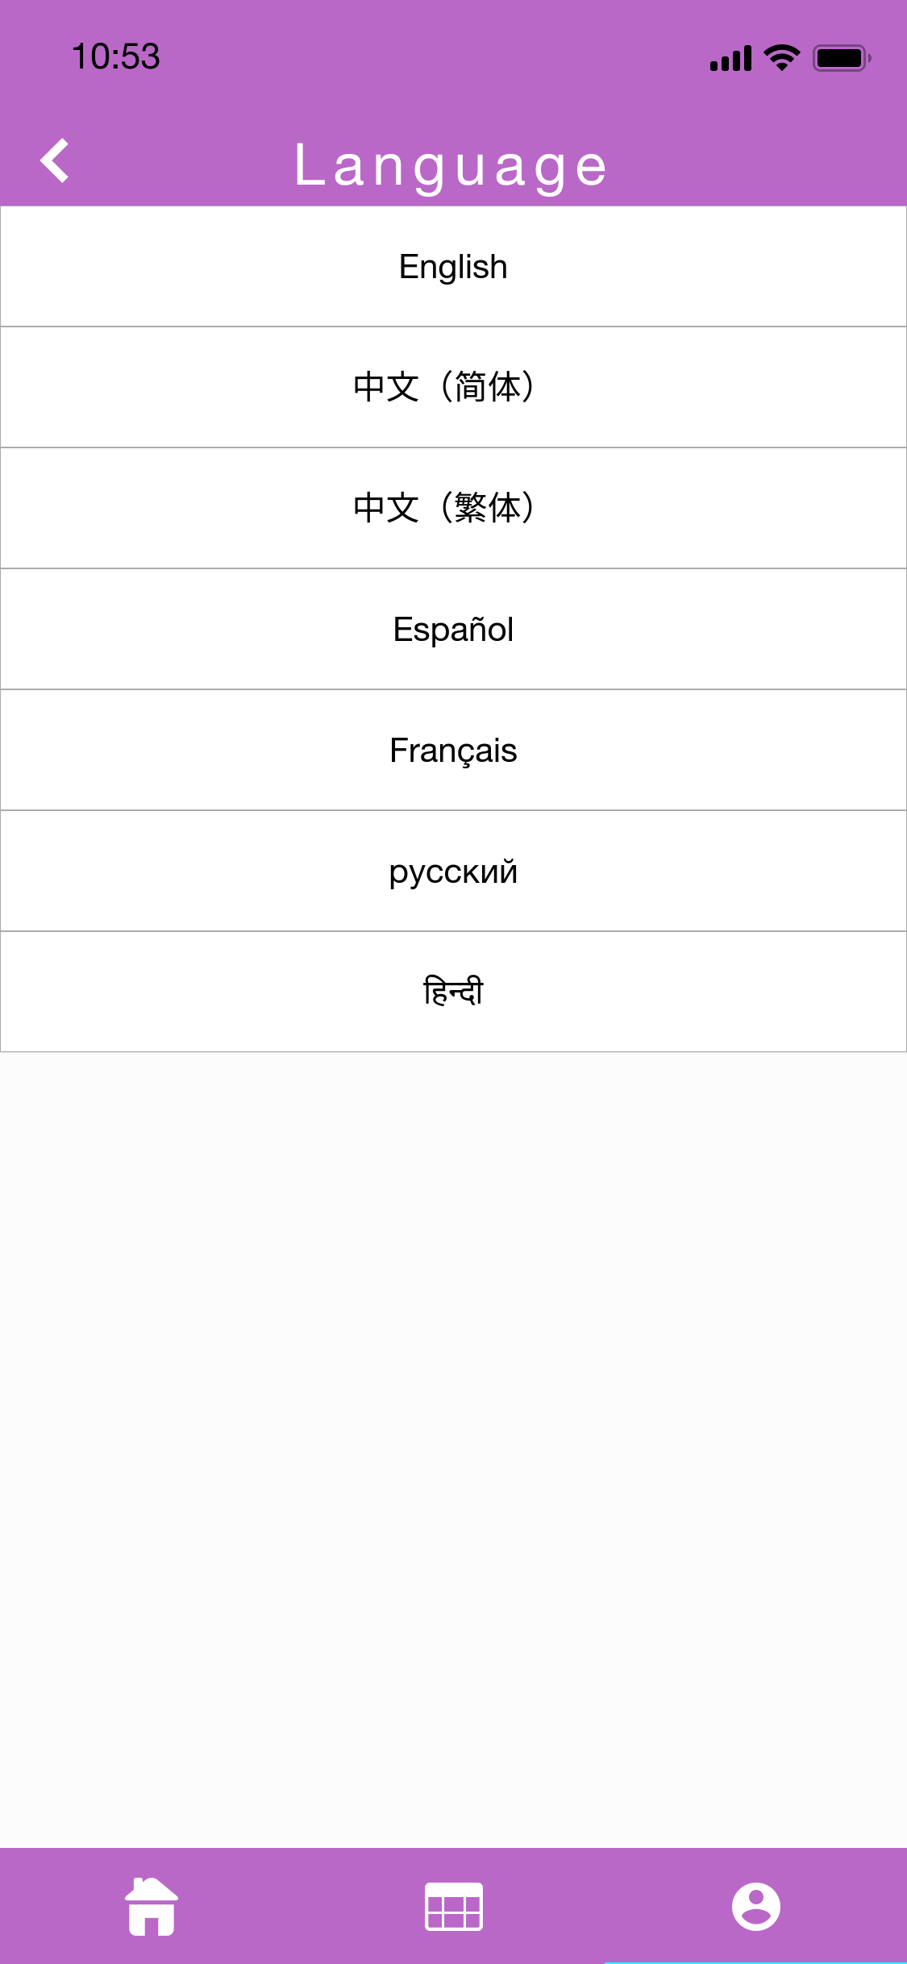

Extended Feature 3 Validation Testing:

For different users from different countries can use the app. If the users can choose the language they use, this function is working properly.

**Author: {Cheng Chen } Create Date: { 07/09/2018}**

# Project Estimation

**{Include estimation spreadsheet and justify}**

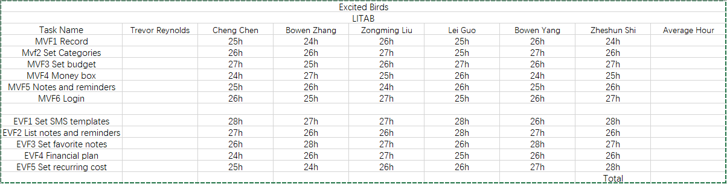

# Technology Listing

## Collaborative Workspaces

1.google doc

<https://drive.google.com/drive/u/0/folders/1CsO1w9nZACLbIzIfCf-IPmvI-VHngsY->

Google doc is the tool our team uses to write reports. Controlled by our tutor and given the permission of our team members to edit.

2.github

<https://github.com/s3665803/excited-bird>

Github is controlled by our team member Bowen Yang and gives us team members permission to edit.

3.trello

<https://trello.com/b/HchjnuLb/tr-excited-birds>

Trello is controlled by our tutor and given the permission of our team members to edit, which can show the progress of our assignment.

## Software

Wechat

a. Short description

WeChat users can share text and pictures with friends through the smartphone client, and support smart phone chat software for group chat and voice and video intercom functions.

b. Rationale

In order to be able to respond in time and propose ideas after class, we create a wechat group, which it can help our group eliminate misunderstandings and improve efficiency.

Basically, six members of our team use WeChat every day to discuss assignments and to check and correct the completed parts.

The connection between each part is powerful despite the fact that each member has there individual parts., in order to guarantee the quality of the assignment, we need to report on the task.

c.Specific version

ios 6.7.2 For free.

App Icon Gear

a. Short description

App Icon Gear is a tool for Mac, iOS developers who want to efficiently make App Icons, Launch Images and Image assets. Gear works perfectly with Xcode.

b. Rationale

It's very convenient to work with Xcode and very simple to operate, which it can quickly suppress pictures of various sizes. We can drag two images at the same time (one horizontal and the other vertical), and Gear will suppress the omnidirectional Launch Image for you.

In addition, currently supported a plenty of types.

12 kinds of iOS App Icon (6 iPhones, 6 iPads)

iOS Launch Image 20 kinds

MAC App Icon 10 kinds

Apple Watch App Icon 8 kinds

Xcode icon set (XC Asset) 3 kinds

c.Specific version

1.5.5 For free.

ADOBE PHOTOSHOP CC

a. Short description

Photoshop is one of Adobe's most famous image processing software, which integrates image scanning, editing and editing, image creation, advertising creativity, image input and output into one image processing software.

b. Rationale

Photoshop is the most powerful drawing software available today. Photoshop's tools are so smart ,which we can use the pens, filters and modes that come with the software to achieve all the effects you can think without any extension. In addition, powerful expandability allows us to perform tasks in a wide variety of pen filters in a wide variety of pen filters.

c.Specific version

V13.0.3

First month is free.

A$39.59/mo (incl. GST)

## Tools

1. Xcode

a. Short description

Xcode is an integrated development environment (IDE) provided by Apple to developers for the development of MacOS, iOS, WatchOS and tvOS applications.

b. Rationale

Because our group will develop a program on the ios platform. Xcode has a unified user interface design, coding, and testing that is the fastest way to develop OS X and iOS applications. Support multi-language programming programs C, C++, Objective-C or Java programming and it can publish the program directly to the App Store. Therefore, the Xcode is the most suitable IDE for our program.

c.Specific version

Xcode 9.4.1 For free.

d. Alternative plan

Eclipse

<https://www.eclipse.org/>

2. proto.io

a. Short description

Proto.io is a dedicated mobile phone prototyping platform that can build and deploy prototypes of fully interactive mobile applications and simulate similar finished products.

b. Rationale

It's convenient for quickly creating an interface because it has a rich set of standard UI elements, and many of them are customizable. In addition, it can be many screens in a project, and transitions can be made between these screens.

c. Specific version

Proto.io 6 Free for 15 days.

d. Alternative plan

invision

<https://www.invisionapp.com/>

## Resources

Github

GitHub is the world's largest code resource hosting sharing site with a lot of resources to learn to help us better complete our application.

# 

# 

# 

# 